**Tea Tree Cultivation Restructured Soil Microbiota in Mountainous Tea Plantations and Regulated Soil Organic Matter Metabolism and Nitrogen Cycling Functions**

Shuaibo Shao 1, 2 andYuanping Li 2, 3, Zhongwei Li 4, Xiaoxiao Ma 4, Yanqi Zhu 2, Yuqing Luo 2, Pumo Cai 2, Xiaoli Jia 2, Christopher Rensing 3, *and Qisong Li 2, *

1 College of Horticulture, Fujian Agriculture and Forestry University, Fuzhou, 350002, China

2 College of Tea and Food, Wuyi University, Wuyishan, 354300, China

3 Institute of Environmental Microbiology, Fujian Agriculture and Forestry University, Fuzhou, 350002, China.

4 College of Resources and Environment, Fujian Agriculture and Forestry University, Fuzhou, 350002, China.

**\*Corresponding author:** Christopher Rensing

**Address:** Fujian Agriculture and Forestry University, No.15 Shangxiadian Road, Fuzhou, Fujian, 350002, China.

**Fax:** +86 0592-6190784, E-mail: [rensing@iue.ac.cn](mailto:rensing@iue.ac.cn)

**\*Corresponding author:** Qisong Li

**Address:** Wuyi University, No.358 Baihua Road, Wuyishan, Fujian, 354300, China.

**Tel:** 13328858241,**Fax:** +86 0599-5137553, **E-mail:** [liqisong0591@126.com](mailto:Liqisong0591@126.com)

**Table S1**. Information of primers used in this study.

|  |  |  |  |
| --- | --- | --- | --- |
| Target | Primers | Primer sequence (5’- 3’) | PCR reaction condition |
| 16S | 338F  806R | ACTCCTACGGGAGGCAGCAG  GGACTACHVGGGTWTCTAAT | 95°C for 3 minutes, 27 cycles of (30 s at 95°C, 30 s at 55°C and 45 s at 72°C, 72°C for 10 minutes) |
| 18S | ITS2-2043 R  ITS5-1737F | GCTGCGTTCTTCATCGATGC  GGAAGTAAAAGTCGTAACAAGG | 95°C for 5 minutes, 35 cycles of (30 s at 94°C, 30 s at 52°C, for 30 s at 72°C，72°C for 10 minutes), |

**Table S2**. Soil physicochemical properties and enzyme activities in different locations of tea plantations (Inter-row (IR), Terrace surfaces (TS), and Terrace wall (TW)) under different cultivation years (1Y, 3Y, 5Y).

|  |  |  |  |  |  |  |  |  |  |  |
| --- | --- | --- | --- | --- | --- | --- | --- | --- | --- | --- |
| TreaTSent | CK | IR1 | IR3 | IR5 | TS1 | TS3 | TS5 | TW1 | TW3 | TW5 |
| Total N（g·kg-1） | 0.83d | 1.39a | 1.15b | 1.01bc | 1.11b | 0.97c | 0.82d | 0.89d | 0.87d | 0.71e |
| Total P（g·kg-1） | 0.63c | 0.82b | 0.97ab | 1.12a | 0.65c | 0.54d | 0.85b | 0.51d | 0.72c | 0.75c |
| Total K（g·kg-1） | 15.25c | 20.88a | 21.67a | 23.54a | 17.26b | 18.44b | 18.95b | 17.62b | 16.83b | 17.09b |
| Available N（mg·kg-1） | 24.67b | 28.29a | 25.43b | 23.88b | 22.56c | 20.85c | 24.05b | 20.92d | 17.70e | 19.45d |
| Available P（mg·kg-1） | 13.8d | 21b | 24.11a | 23.03a | 15.52c | 17.81c | 20.28b | 11.74e | 13.59d | 16.33c |
| Available K（mg·kg-1） | 84.639e | 106.19b | 115.14ab | 121.54a | 90.88d | 97.55c | 107.18b | 98.36c | 89.14d | 85.93e |
| Organic matter（g·kg-1） | 21.37a | 18.68ab | 17.15bc | 15.6de | 16.56cd | 15.68de | 12.76f | 13.76f | 11.87f | 11.91f |
| pH | 4.54c | 4.6b | 4.53c | 4.45d | 4.58bc | 4.56bc | 4.52c | 4.65a | 4.58bc | 4.54bc |
| Urase[mg/(g·d)] | 0.77bc | 1.04a | 0.89b | 0.82b | 0.62c | 0.65c | 0.88b | 0.52cd | 0.41d | 0.59cd |
| Polyphenoloxidase[mg/(g·2h)] | 0.73e | 1.38c | 1.66b | 1.95a | 0.80de | 0.97e | 1.18cd | 0.62e | 0.58e | 0.76e |
| Acid phosphatase[mg/(g·h)] | 0.98 c | 1.50a | 0.89d | 1.27ab | 1.19ab | 0.85d | 0.74e | 0.99c | 0.87d | 0.79d |
| Protease[mg/(g·d)] | 0.184c | 0.204c | 0.38a | 0.44a | 0.19c | 0.33b | 0.31b | 0.18c | 0.21b | 0.29b |
| Peroxidase[mg/(g·2h)] | 0.97d | 1.33c | 1.68b | 1.94a | 1.3c | 1.1cd | 1.39d | 0.99d | 0.95d | 1.25cd |
| Cellulase[mg/(g·d)] | 0.17e | 0.16e | 0.27c | 0.37a | 0.14f | 0.24c | 0.32b | 0.15ef | 0.21d | 0.22d |

Notes: different letters denote significant differences (LSD, P < 0.05)**Table S3**. The study analyzed the topological characteristics of bacterial community co-occurrence networks in three types of soil: Inter-row (IR), Terrace surfaces (TS), and Terrace wall (TW), under different tea cultivation durations (1Y, 3Y, 5Y).

|  |  |  |  |  |  |  |  |  |  |
| --- | --- | --- | --- | --- | --- | --- | --- | --- | --- |
| BACTERIA-Summary Statistics | IR1 | IR3 | IR5 | TS1 | TS3 | TS5 | TW1 | TW3 | TW5 |
| Number of nodes | 193 | 177 | 137 | 176 | 115 | 94 | 137 | 146 | 143 |
| Number of edges | 1549 | 861 | 643 | 1127 | 746 | 545 | 822 | 870 | 607 |
| Avg. number of neighbors | 44 | 16 | 18 | 33 | 30 | 19 | 24 | 19 | 16 |
| Connected components | 32 | 32 | 29 | 24 | 24 | 12 | 25 | 25 | 30 |
| Analysis time (sec） | 0.079 | 0.067 | 0.018 | 0.094 | 0.029 | 0.019 | 0.014 | 0.025 | 0.051 |

**Table S4**. The study analyzed the topological characteristics of fungus community co-occurrence networks in three types of soil: Inter-row (IR), Terrace surfaces (TS), and Terrace wall (TW), under different tea cultivation durations (1Y, 3Y, 5Y).

|  |  |  |  |  |  |  |  |  |  |
| --- | --- | --- | --- | --- | --- | --- | --- | --- | --- |
| FUNGI-Summary Statistics | IR1 | IR3 | IR5 | TS1 | TS3 | TS5 | TW1 | TW3 | TW5 |
| Number of nodes | 139 | 145 | 199 | 160 | 106 | 161 | 86 | 136 | 153 |
| Number of edges | 668 | 977 | 1832 | 1039 | 553 | 1335 | 450 | 1068 | 1335 |
| Avg. number of neighbors | 20 | 26 | 35 | 27 | 20 | 28 | 20 | 28 | 28 |
| Connected components | 22 | 19 | 21 | 21 | 12 | 25 | 12 | 16 | 17 |
| Analysis time (sec） | 0.022 | 0.021 | 0.075 | 0.02 | 0.017 | 0.079 | 0.08 | 0.028 | 0.051 |

**Table S5**. Proportion of variance for PCoA analysis of soil microbial communities.

|  |  |  |
| --- | --- | --- |
| Proportion of Variance | Bacteria | fungi |
| PC1 | 0.3627 | 0.4702 |
| PC2 | 0.245 | 0.1604 |
| PC3 | 0.117 | 0.0669 |
| PC4 | 0.0553 | 0.0575 |
| PC5 | 0.0404 | 0.0533 |
| PC6 | 0.0287 | 0.0454 |
| PC7 | 0.0218 | 0.0315 |
| PC8 | 0.0158 | 0.0305 |
| PC9 | 0.0143 | 0.0277 |
| PC10 | 0.0101 | 0.0105 |
| PC11 | 0.0099 | 0.0098 |
| PC12 | 0.009 | 0.0083 |
| PC13 | 0.0077 | 0.0067 |
| PC14 | 0.0068 | 0.0048 |
| PC15 | 0.0062 | 0.004 |
| PC16 | 0.0059 | 0.0028 |
| PC17 | 0.0056 | 0.0023 |
| PC18 | 0.0052 | 0.002 |
| PC19 | 0.0045 | 0.0017 |
| PC20 | 0.0041 | 0.0009 |
| PC21 | 0.0036 | 0.0008 |
| PC22 | 0.0033 | 0.0006 |
| PC23 | 0.0031 | 0.0005 |
| PC24 | 0.0028 | 0.0004 |
| PC25 | 0.0025 | 0.0002 |
| PC26 | 0.0025 | 0.0002 |
| PC27 | 0.0024 | 0.0001 |
| PC28 | 0.0022 | 0 |
| PC29 | 0.0018 | 0 |
| PC30 | 0 | 0.0001 |

**Table S6**. Parameters related to Neutral community mode (NCM) for different soil microbial communities.

|  |  |  |  |  |  |
| --- | --- | --- | --- | --- | --- |
| Neutral community model (NCM) data | | | | | |
|
| GROUP | | R2 | N | m | Nm |
| Bacteria | IR | 0.7767 | 47501 | 0.6411 | 30452.1894 |
| TS | 0.7953 | 47501 | 0.6392 | 30360.6524 |
| TW | 0.799 | 47501 | 0.6268 | 29771.7668 |
| Fungi | IR | 0.5064 | 63214 | 0.186 | 11755.5085 |
| TS | 0.4785 | 63214 | 0.1574 | 9952.4611 |
| TW | 0.4311 | 63214 | 0.1319 | 8338.0233 |

Notes: The R2 value represents the overall goodness of fit of the Neutral Community Model; The migration rate (m) quantifies the community-level dispersal and is consistent for all community members; N describes the metacommunity size, which is the total abundance of all OTUs in each sample; Nm, which is the product of the community size (N) and mobility (m) (Nm = N*m), quantifies estimates of dispersal between communities.

**Table S7**. Proportion of variance for RDA analysis of soil microbial communities.

|  |  |  |
| --- | --- | --- |
| **Proportion of Variance** | **Bacteria** | **Fungi** |
| RDA1 | 0.7375 | 0.4448 |
| RDA2 | 0.1083 | 0.1789 |
| RDA3 | 0.0585 | 0.132 |
| RDA4 | 0.0361 | 0.1003 |
| RDA5 | 0.0082 | 0.0448 |
| RDA6 | 0.0063 | 0.0328 |
| RDA7 | 0.005 | 0.0155 |
| RDA8 | 0.0044 | 0.0104 |
| RDA9 | 0.0024 | 0.0059 |
| RDA10 | 0.002 | 0.0016 |
| RDA11 | 0.0015 | 0.0003 |
| RDA12 | 0.0008 | 0.0002 |
| RDA13 | 0.0006 | 0.0001 |
| RDA14 | 0.0005 | 0 |
| RDA15 | 0.0003 | 0.0183 |
| PC1 | 0.0102 | 0.0048 |
| PC2 | 0.0074 | 0.0032 |
| PC3 | 0.0034 | 0.0027 |
| PC4 | 0.0019 | 0.0013 |
| PC5 | 0.0012 | 0.0009 |
| PC6 | 0.0012 | 0.0005 |
| PC7 | 0.0008 | 0.0003 |
| PC8 | 0.0006 | 0.0002 |
| PC9 | 0.0005 | 0.0001 |
| PC10 | 0.0002 | 0 |
| PC11 | 0.0002 | 0 |

**Table S8**. The significant relationships between soil physicochemical properties and enzyme activity with soil microbial community in the RDA analysis.

|  |  |  |  |  |
| --- | --- | --- | --- | --- |
|  | RDA1 | RDA2 | ef.vectors.r | ef.vectors.pvals |
| N | -0.728432024 | 0.685118082 | 0.337864069 | 0.007 |
| P | -0.737882219 | 0.674929501 | 0.251034834 | 0.032 |
| K | -0.868337774 | -0.495973296 | 0.117854547 | 0.202 |
| AN | -0.386297049 | -0.92237443 | 0.302249955 | 0.016 |
| AP | -0.595903079 | 0.803056362 | 0.556214234 | 0.001 |
| AK | -0.459006714 | 0.888432798 | 0.134942857 | 0.176 |
| SOM | 0.871358788 | -0.490646372 | 0.500794614 | 0.002 |
| MC | 0.484883836 | -0.874578565 | 0.749063285 | 0.001 |
| pH | 0.736842608 | -0.676064325 | 0.666486575 | 0.001 |
| UE | -0.819457583 | -0.573139835 | 0.333174052 | 0.007 |
| PPO | -0.980200395 | 0.198008046 | 0.373871002 | 0.001 |
| ACP | -0.086092111 | -0.996287182 | 0.328573436 | 0.01 |
| POD | -0.426002887 | 0.904721802 | 0.507809024 | 0.001 |
| PT | -0.686977174 | 0.726678995 | 0.724757134 | 0.001 |
| CE | -0.508040508 | 0.861333177 | 0.759204456 | 0.001 |

**Table S9.** Structural equation modeling parameters and Confidence index (Fig 6C).

|  |  |  |  |  |
| --- | --- | --- | --- | --- |
| Summary table of model regression coefficients | | | | |
| X | → | Y | p | Regression coefficient |
| soil location | → | N nutrient | 0.04 | -0.52 |
| soil location | → | Bacteria diversity | 0.14 | 0.29 |
| soil location | → | Nitrification function | 0.01 | -0.44 |
| soil location | → | Denitrification function | 0.00 | -0.76 |
| soil location | → | organic matter | 0.01 | -0.72 |
| soil location | → | Fungi diversity | 0.68 | 0.09 |
| soil location | → | saprotroph function | 0.45 | 0.20 |
| soil location | → | Plant pathogen function | 0.02 | -0.43 |
| Bacteria diversity | → | N nutrient | 0.00 | 0.65 |
| Bacteria diversity | → | Nitrification function | 0.00 | 0.67 |
| Bacteria diversity | → | Denitrification function | 0.01 | -0.71 |
| Fungi diversity | → | Plant pathogen function | 0.02 | 0.42 |
| Fungi diversity | → | saprotroph function | 0.04 | 0.30 |
| Fungi diversity | → | organic matter | 0.02 | -0.42 |
| Nitrification function | → | N nutrient | 0.05 | 0.35 |
| Denitrification function | → | N nutrient | 0.01 | 0.45 |
| Plant pathogen function | → | organic matter | 0.66 | 0.15 |
| saprotroph function | → | organic matter | 0.02 | 0.45 |

Note：→Representing the regression relationships

|  |  |  |  |  |  |  |  |  |
| --- | --- | --- | --- | --- | --- | --- | --- | --- |
| Confidence index | χ2/df | p | GFI | RMSEA | RMR | CFI | NFI | NNFI |
| value | 1.247 | 0.085 | 0.541 | 0.017 | 0.037 | 0.932 | 0.918 | 0.619 |
| Confidence index | TLI | AGFI | IFI | PGFI | PNFI | PCFI | SRMR |  |
| value | 0.9 | 0.85 | 0.907 | 0.479 | 0.568 | 0.466 | 0.097 |  |

Note: Confidence index

**Table S10.** Structural equation modeling parameters and Confidence index (Fig 6D).

|  |  |  |  |  |
| --- | --- | --- | --- | --- |
| Summary table of model regression coefficients | | | | |
| X | → | Y | p | Regression coefficient |
| Planting Years | → | N nutrient | 0.08 | -0.42 |
| Planting Years | → | Bacteria diversity | 0.00 | -0.88 |
| Planting Years | → | Nitrification function | 0.01 | -0.61 |
| Planting Years | → | Denitrification function | 0.00 | 0.81 |
| Planting Years | → | organic matter | 0.00 | -0.87 |
| Planting Years | → | Fungi diversity | 0.44 | 0.18 |
| Planting Years | → | saprotroph function | 0.01 | 0.67 |
| Planting Years | → | Plant pathogen function | 0.02 | 0.39 |
| Bacteria diversity | → | N nutrient | 0.03 | 0.39 |
| Bacteria diversity | → | Nitrification function | 0.00 | 0.90 |
| Bacteria diversity | → | Denitrification function | 0.01 | -0.57 |
| Fungi diversity | → | Plant pathogen function | 0.02 | 0.39 |
| Fungi diversity | → | saprotroph function | 0.03 | -0.23 |
| Fungi diversity | → | organic matter | 0.03 | 0.27 |
| Nitrification function | → | N nutrient | 0.01 | 0.75 |
| Denitrification function | → | N nutrient | 0.01 | -0.48 |
| Plant pathogen function | → | organic matter | 0.00 | -0.81 |
| saprotroph function | → | organic matter | 0.01 | -0.57 |

Note：→Representing the regression relationships

|  |  |  |  |  |  |  |  |  |
| --- | --- | --- | --- | --- | --- | --- | --- | --- |
| Confidence index | χ2/df | p | GFI | RMSEA | RMR | CFI | NFI | NNFI |
| value | 1.351 | 0.058 | 0.5 | 0.074 | 0.04 | 0.918 | 0.686 | 0.871 |
| Confidence index | TLI | AGFI | IFI | PGFI | PNFI | PCFI | SRMR |  |
| value | 0.871 | 0.247 | 0.918 | 0.332 | 0.52 | 0.66 | 0.036 |  |

Note: Confidence index

**Table S11.** Microbial genera functions and corresponding references.

|  |  |  |
| --- | --- | --- |
| Genus | Funtions | References |
| *Burkholderia* | Nitrogen fixation | (Lin et al., 2012; Zhong et al., 2022) |
| *Bradyrhizobium* | Nitrogen fixation，Nitrogen transformation | (Sharma et al., 2020; Ormeño-Orrillo and Martínez-Romero, 2019) |
| *Gemmatimonas* | Nitrogen fixation，Nitrogen transformation | (Park et al., 2017; Oshiki et al., 2022) |
| *Xanthobacter* | Nitrogen fixation，Conversion of plant hormones | (Juan et al., 2022) |
| *Chujaibacter* | Degradation, Organic metabolism | (Feng et al., 2023) |
| *Candidatus_Solibacter* | Degradation, Organic metabolism | (Wang et al., 2017; Wang et al., 2022) |
| *Sphingomonas* | Soil remediation, Organic metabolism | (Luo et al., 2019; Asaf et al., 2020) |
| *Kitasatospora* | Organic metabolism | (Rahmani et al., 2019; Klaysubun et al., 2022) |
| *Sinomonas* | Amylolytic, Organic metabolism | (Lee et al., 2015; Narsing Rao et al., 2018) |
| *Bryobacter* | Soil remediation, Organic metabolism | (Li et al., 2021; Hu et al., 2022) |
| *Granulicella* | Organic metabolism | (Costa et al., 2020) |
| *Cladosporium* | Mildew | (Simão and Gomes, 2001; Prasannath et al., 2021) |
| *Curvularia* | Cuvularia leaf spot | (Zhang et al., 2019) |
| *Sarocladium* | Cause Brown Spot, Rice Sheath Rot | (Hou et al., 2019; Peeters et al., 2020) |
| *Fusarium* | Leaf blight, Mildew | (Rai et al., 2020) |
| *Geminibasidium* | Organic metabolism, Disease resistance | (Pulido-Chavez et al., 2021; Ren et al., 2021) |
| *Gongronella* | Solubilizing capacity, Organic metabolism | (Doilom et al., 2020) |
| *Penicillium* | Cellulose degradation | (Vaishnav et al., 2018) |
| *Talaromyces* | Cellulose degradation, Lignin degradation | (Houbraken et al., 2020; Méndez-Líter et al., 2021) |
| *Trichoderma* | Cellulose Degradation, Disease resistance | (Sood et al., 2020; Zin and Badaluddin, 2020) |

**Fig. S1**. The co-occurrence networks of bacterial communities in different soils under varying tea cultivation durations.

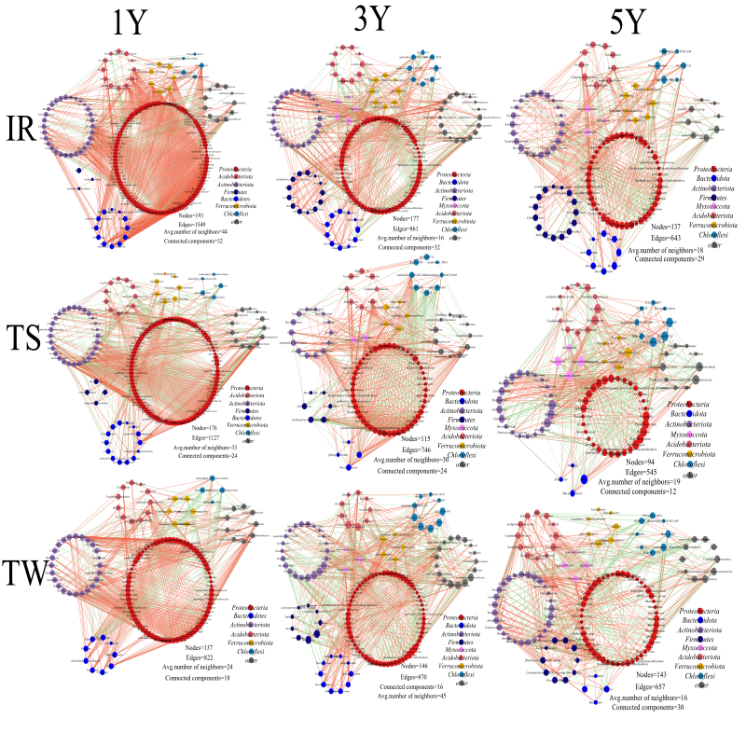

Notes: Different circle colors represent different Phylums(Spearman,P<0.01,r> 0.70).

**Fig. S2**. The co-occurrence networks of fungus communities in different soils under varying tea cultivation durations.

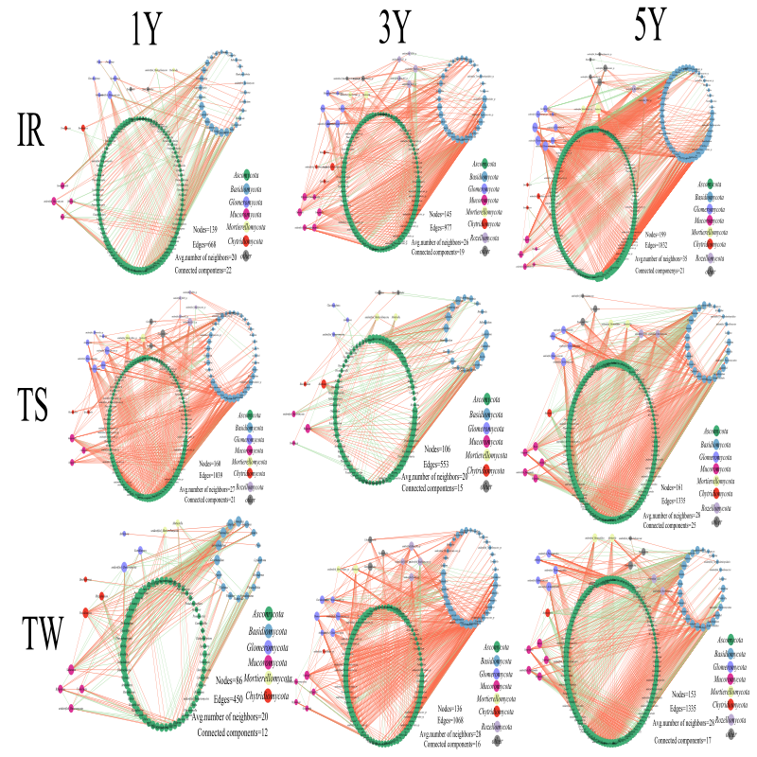

Notes: Different circle colors represent different Phylum (Spearman<0.01,r> 0.70).

**Fig. S3.** LEfSe analysis of distinctive bacteria in different soil types (Figure4A.B.C).

s3

Notes: A: Inter-row (IR), B: Terrace surfaces (TS), C: Terrace wall (TW). Different column colors represent different years of the same sample. (LDA > 3.5). D: LEfSe multilevel species hierarchy tree. Different colored nodes indicate the microbial taxa that were significantly enriched in the corresponding groups and had a significant impact on the differences between groups.

**Fig. S4.** LEfSe analysis of distinctive fungi in different soil types (Figure5A.B.C)

S4

Notes: A: Inter-row (IR), B:Terrace surfaces (TS), C: Terrace wall (TW).Different column colors represent different years of the same sample. (LDA > 3.5). D:LEfSe multilevel species hierarchy tree.Different colored nodes indicate the microbial taxa that were significantly enriched in the corresponding groups and had a significant impact on the differences between group

**References**

Asaf, S., Numan, M., Khan, A.L., Al-Harrasi, A., 2020. *Sphingomonas*: from diversity and genomics to functional role in environmental remediation and plant growth. Critical Reviews In Biotechnology 40, 138-152.

Costa, O.Y.A., de Hollander, M., Pijl, A., Liu, B., Kuramae, E.E., 2020. Cultivation-independent and cultivation-dependent metagenomes reveal genetic and enzymatic potential of microbial community involved in the degradation of a complex microbial polymer. Microbiome 8, 76.

Doilom, M., Guo, J.W., Phookamsak, R., Mortimer, P.E., Karunarathna, S.C., Dong, W., Liao, C.F., Yan, K., Pem, D., Suwannarach, N., Promputtha, I., Lumyong, S., Xu, J.C., 2020. Screening of Phosphate-Solubilizing Fungi From Air and Soil in Yunnan, China: Four Novel Species in *Aspergillus*, *Gongronella*, *Penicillium*, and *Talaromyces*. Front in Microbiol 11, 585215.

Feng, C., Yi, Z., Qian, W., Liu, H., Jiang, X., 2023. Rotations improve the diversity of *rhizosphere* soil bacterial communities, enzyme activities and tomato yield. Public Library of Science ONE 18, e0270944.

Hou, Y.M., Zhang, X., Zhang, N.N., Naklumpa, W., Zhao, W.Y., Liang, X.F., Zhang, R., Sun, G.Y., Gleason, M.L., 2019. Genera *Acremonium* and *Sarocladium* Cause Brown Spot on Bagged Apple Fruit in China. Plant Disease 103, 1889-1901.

Houbraken, J., Kocsubé, S., Visagie, C.M., Yilmaz, N., Wang, X.C., Meijer, M., Kraak, B., Hubka, V., Bensch, K., Samson, R.A., Frisvad, J.C., 2020. Classification of *Aspergillus*, *Penicillium*, *Talaromyces* and related genera (Eurotiales): An overview of families, genera, subgenera, sections, series and species. Studies in Mycology 95, 5-169.

Hu, L., Li, Q., Yan, J., Liu, C., Zhong, J., 2022. Vegetation restoration facilitates belowground microbial network complexity and recalcitrant soil organic carbon storage in southwest China karst region. Science of The Total Environment 820, 153137.

Juan Manuel, S.-Y., 2022. *Xanthobacter* autotrophicus an Endophytic Beneficial Bacterium for Wheat and Other Plants: A Short Review, In: Mahmood-ur-Rahman, A. (Ed.), Current Trends in Wheat Research. IntechOpen, Rijeka, p. Ch. 4.

Klaysubun, C., Srisuk, N., Duangmal, K., 2022. Kitasatospora humi sp. nov., isolated from a tropical peat swamp forest soil, and proposal for the reclassification of *Kitasatospora* psammotica as a later heterotypic synonym of *Kitasatospora* aureofaciens. International Journal of Systematic and Evolutionary Microbiology 72.

Lee, L.H., Azman, A.S., Zainal, N., Yin, W.F., Mutalib, N.A., Chan, K.G., 2015. *Sinomonas* humi sp. nov., an amylolytic actinobacterium isolated from mangrove forest soil. International Journal of Systematic and Evolutionary Microbiology 65, 996-1002.

Li, B., Xu, R., Sun, X., Han, F., Xiao, E., Chen, L., Qiu, L., Sun, W., 2021. Microbiome-environment interactions in antimony-contaminated rice paddies and the correlation of core microbiome with arsenic and antimony contamination. Chemosphere 263, 128227.

Lin, L., Li, Z., Hu, C.-j., Zhang, X.-c., Chang, S., Yang, L.-T., Li, Y., An, Q., 2012. Plant Growth-Promoting Nitrogen-Fixing Enterobacteria Are in Association with Sugarcane Plants Growing in Guangxi, China. Microbes and Environments 27, 391 - 398.

Luo, Y., Wang, F., Huang, Y., Zhou, M., Gao, J., Yan, T., Sheng, H., An, L., 2019. *Sphingomonas* sp. Cra20 Increases Plant Growth Rate and Alters Rhizosphere Microbial Community Structure of Arabidopsis thaliana Under Drought Stress. Front in Microbiol 10, 1221.

Méndez-Líter, J.A., de Eugenio, L.I., Nieto-Domínguez, M., Prieto, A., Martínez, M.J., 2021. *Hemicellulases* from *Penicillium* and *Talaromyces* for lignocellulosic biomass valorization: A review. Bioresource Technology 324, 124623.

Narsing Rao, M.P., Xiao, M., Li, W.-J., 2018. Chapter 12 - Characterization of the Genus *Sinomonas*: From Taxonomy to Applications, In: Singh, B.P., Gupta, V.K., Passari, A.K. (Eds.), New and Future Developments in Microbial Biotechnology and Bioengineering. Elsevier, pp. 179-190.

Ormeño-Orrillo, E., Martínez-Romero, E., 2019. A Genomotaxonomy View of the Bradyrhizobium Genus. Front Microbiol 10, 1334.

Oshiki, M., Toyama, Y., Suenaga, T., Terada, A., Kasahara, Y., Yamaguchi, T., Araki, N., 2022. N2O Reduction by *Gemmatimonas aurantiaca* and Potential Involvement of *Gemmatimonadetes* Bacteria in N2O Reduction in Agricultural Soils. Microbes and Environments 37.

Park, D., Kim, H., Yoon, S., 2017. Nitrous Oxide Reduction by an Obligate Aerobic Bacterium, *Gemmatimonas* aurantiaca Strain T-27. Applied and Environmental Microbiology 83, e00502-00517.

Peeters, K.J., Haeck, A., Harinck, L., Afolabi, O.O., Demeestere, K., Audenaert, K., Höfte, M., 2020. Morphological, Pathogenic and Toxigenic Variability in the Rice Sheath Rot Pathogen Sarocladium Oryzae. Toxins 12, 109.

Prasannath, K., Shivas, R.G., Galea, V.J., Akinsanmi, O.A., 2021. Novel Botrytis and Cladosporium Species Associated with Flower Diseases of Macadamia in Australia. Journal of Fungi 7, 898.

Pulido-Chavez, M.F., Alvarado, E.C., DeLuca, T.H., Edmonds, R.L., Glassman, S.I., 2021. High-severity wildfire reduces richness and alters composition of ectomycorrhizal fungi in low-severity adapted ponderosa pine forests. Forest Ecology and Management 485, 118923.

Rahmani, N., Kahar, P., Lisdiyanti, P., Lee, J., Yopi, Prasetya, B., Ogino, C., Kondo, A., 2019. GH-10 and GH-11 Endo-1,4-β-xylanase enzymes from Kitasatospora sp. produce xylose and xylooligosaccharides from sugarcane bagasse with no xylose inhibition. Bioresour Technol 272, 315-325.

Rai, A., Das, M., Tripathi, A., 2020. Occurrence and toxicity of a fusarium mycotoxin, zearalenone. Crit Rev Food Sci Nutr 60, 2710-2729.

Ren, H., Wang, H., Qi, X., Yu, Z., Zheng, X., Zhang, S., Wang, Z., Zhang, M., Ahmed, T., Li, B., 2021. The Damage Caused by Decline Disease in Bayberry Plants through Changes in Soil Properties, Rhizosphere Microbial Community Structure and Metabolites. Plants 10, 2083.

Sharma, V., Bhattacharyya, S., Kumar, R., Kumar, A., Ibañez, F., Wang, J., Guo, B., Sudini, H.K., Gopalakrishnan, S., DasGupta, M., Varshney, R.K., Pandey, M.K., 2020. Molecular Basis of Root Nodule Symbiosis between *Bradyrhizobium* and ‘Crack-Entry’ Legume Groundnut (*Arachis hypogaea* L.). Plants 9, 276.

Simão, R.C., Gomes, S.L., 2001. Structure, expression, and functional analysis of the gene coding for calmodulin in the chytridiomycete Blastocladiella emersonii. J Bacteriol 183, 2280-2288.

Sood, M., Kapoor, D., Kumar, V., Sheteiwy, M.S., Ramakrishnan, M., Landi, M., Araniti, F., Sharma, A., 2020. Trichoderma: The "Secrets" of a Multitalented Biocontrol Agent. Plants (Basel) 9.

Vaishnav, N., Singh, A., Adsul, M., Dixit, P., Sandhu, S.K., Mathur, A., Puri, S.K., Singhania, R.R., 2018. Penicillium: The next emerging champion for cellulase production. Bioresource Technology Reports 2, 131-140.

Zhong, Y., Liang, L., Xu, R., Xu, H., Sun, L., Liao, H., 2022. Intercropping tea plantations with soybean and rapeseed enhances nitrogen fixation through shifts in soil microbial communities. Frontiers of Agricultural Science and Engineering 9, 344-355.